Project Title : ONLINE PROPERTY SALE.

REQUIREMENT :

In this project we have used three modules :

1] administration

2] owner

3] Buyer

1] Administrator Module :

* Administrator can validate properties and register accounts.
* Admin can remove invalidate properties and register accounts.

2]Owner Module :

- Owner can register and create his account.

-Owner can remove his property from listing.

- Owner see and manage customer requests who interested in respective propert

- Owner can confirm deal with customer privately.

- Owner can see and manage his properties.

3] Buyer Module :

- Buyer register and create his own account.

- Buyer rent a property by contacting property owner.

-Buyer request for owner information as well as property information.

Admin use case :

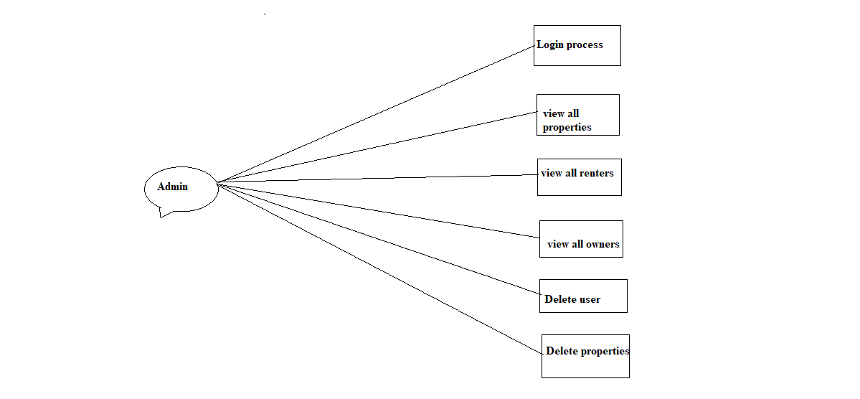

Owner use case :

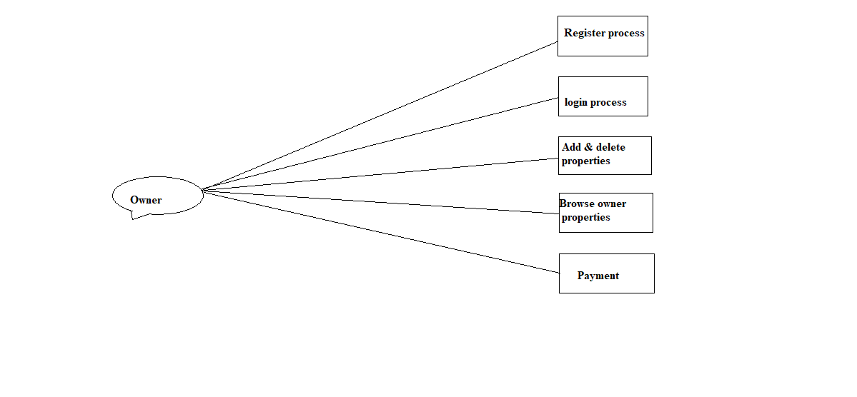

Buyer use case :

